**DEPARTMENT OF INFORMATION TECHNOLOGY**

**Course: Data Mining & Business Intelligence Lab (ITL601)**

**B.Tech. (Information Technology) – Semester VI**

**Academic Year: 2023-24 (Even Semester)**

**PRACTICAL 6**

**Aim:** Implement and evaluate any Classification Algorithm using Python

**Lab Objective:** To learn how to gather and analyze large sets of data to gain useful business understanding.

**Theory:**

Classification algorithms are a fundamental component of machine learning, used to predict categorical labels or classes for given input data. Python, with its extensive libraries such as sci-kit-learn, TensorFlow, and PyTorch, provides a versatile platform for implementing and evaluating classification algorithms.

Implementing and evaluating a classification algorithm in Python involves several key steps:

1. Data Preparation:

- Import the necessary libraries.

- Load your dataset into Python, which may involve using libraries like Pandas for structured data or NumPy for numerical arrays.

- Preprocess your data, which may include handling missing values, encoding categorical variables, and scaling features to ensure they have similar ranges.

2. Splitting Data:

- Split your dataset into two subsets: training data and testing data. The training set is used to train the model, while the testing set is used to evaluate its performance.

3. Choosing a Classification Algorithm:

- Select a classification algorithm based on the nature of your data and the problem you are trying to solve. Common algorithms include logistic regression, decision trees, random forests, support vector machines (SVM), k-nearest neighbors (KNN), and neural networks.

4. Model Training:

- Train your chosen classification algorithm using the training data. This involves fitting the model to the training data so that it can learn the underlying patterns and relationships.

5. Model Evaluation:

- Evaluate the trained model using the testing data to assess its performance. Common evaluation metrics for classification tasks include accuracy, precision, recall, F1-score, and area under the ROC curve (AUC-ROC).

- Generate a confusion matrix to visualize the model's predictions and identify any misclassifications.

- Use cross-validation techniques to obtain more reliable estimates of the model's performance by splitting the data into multiple train-test sets.

6. Hyperparameter Tuning (Optional):

- Fine-tune the hyperparameters of your classification algorithm to optimize its performance. This can be done using techniques like grid search or randomized search, where you search over a predefined set of hyperparameters and select the combination that yields the best performance.

7. Implementation Best Practices:

- Use proper data visualization techniques to gain insights into your dataset and understand the relationships between variables.

- Handle imbalanced datasets carefully by using techniques like oversampling, undersampling, or using algorithms that are robust to class imbalances.

- Perform feature selection or dimensionality reduction if your dataset has a large number of features to improve computational efficiency and model interpretability.

- Regularize your models to prevent overfitting and improve generalization to unseen data.

By following these steps, you can implement and evaluate classification algorithms in Python effectively, enabling you to make informed decisions and predictions based on your data.

**Schema Designs / <Code with Output>:**

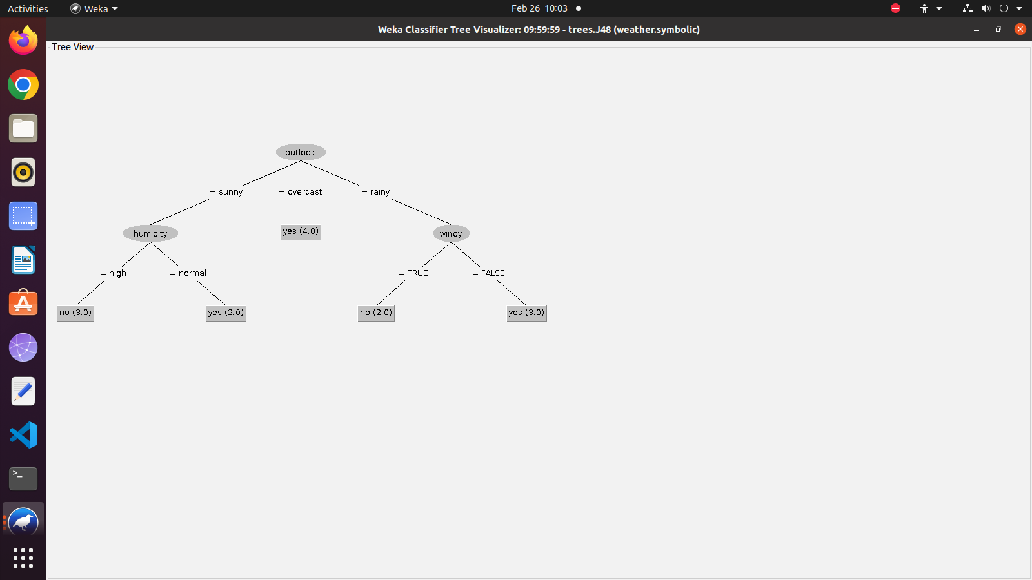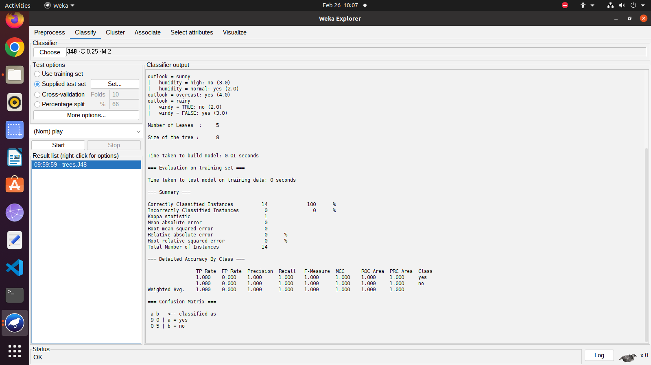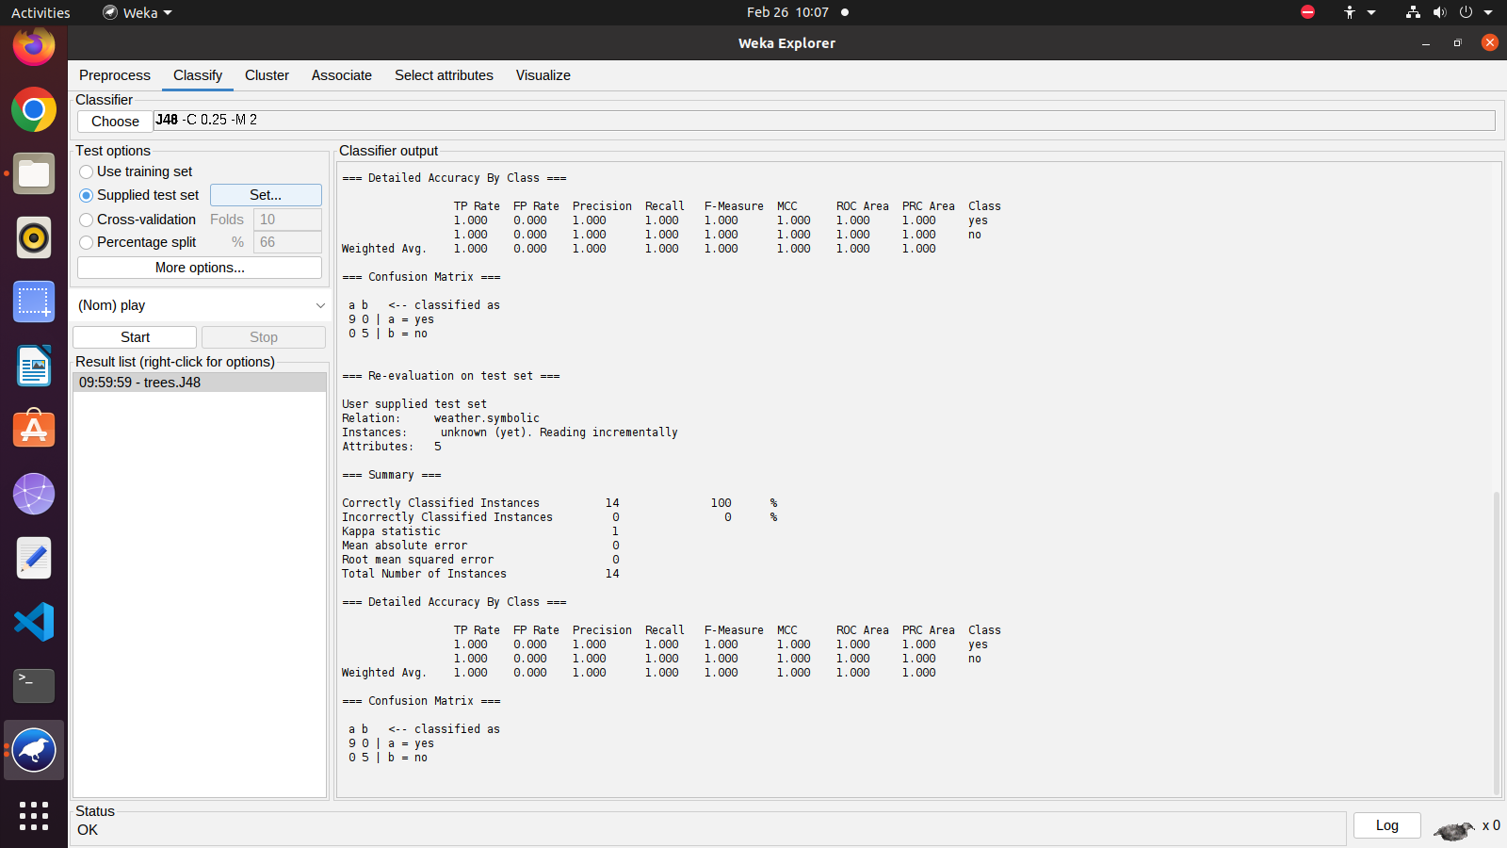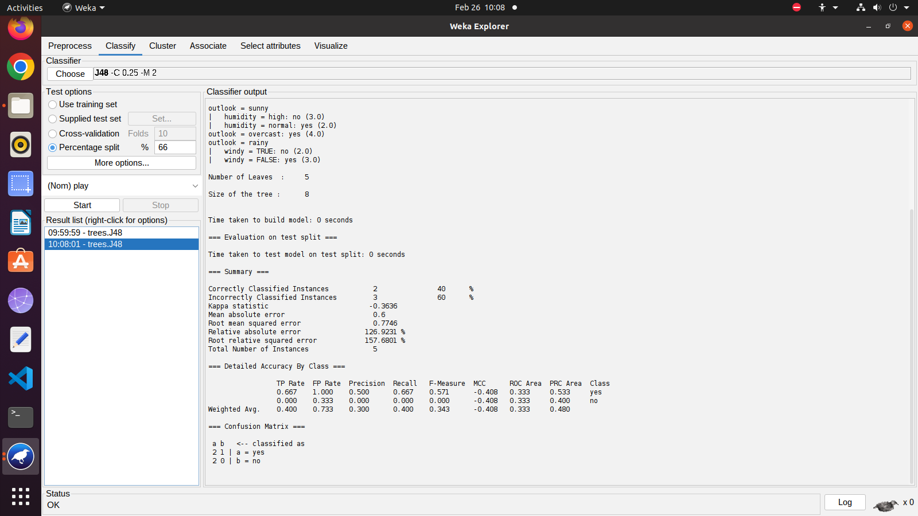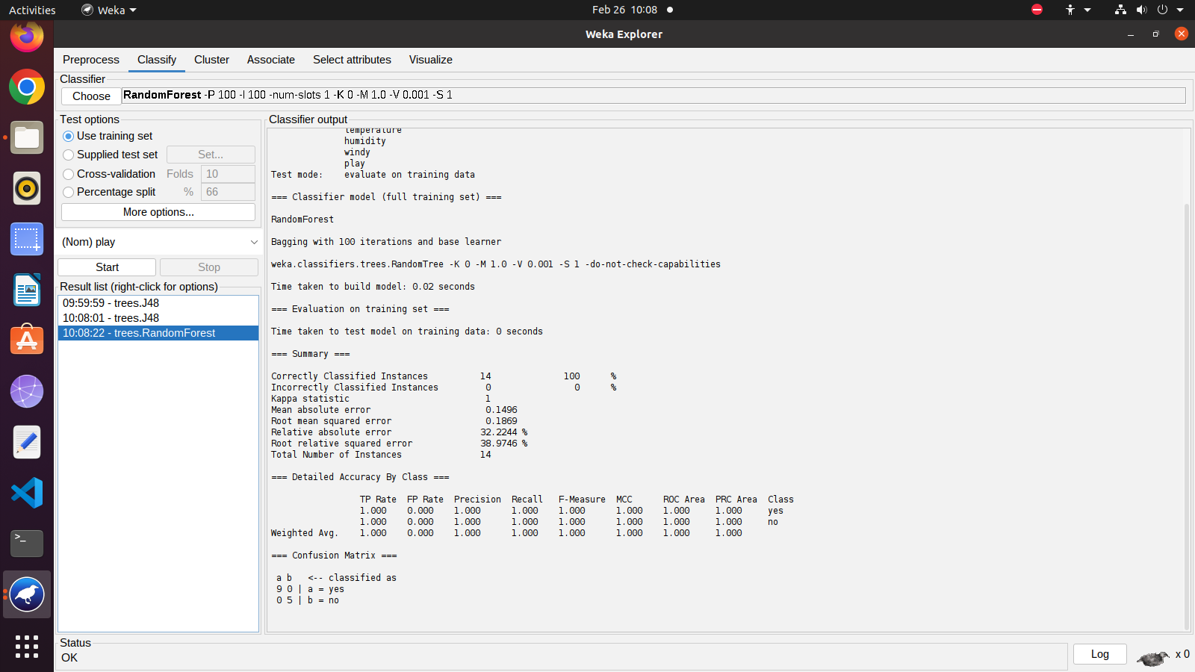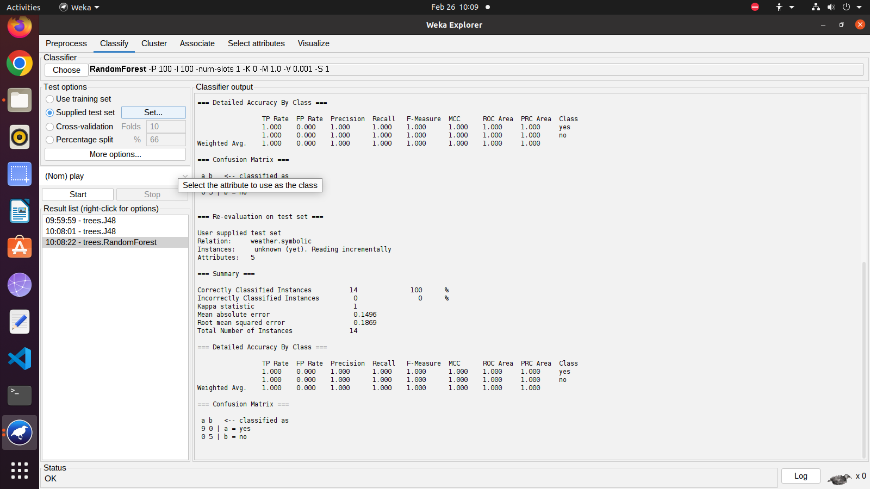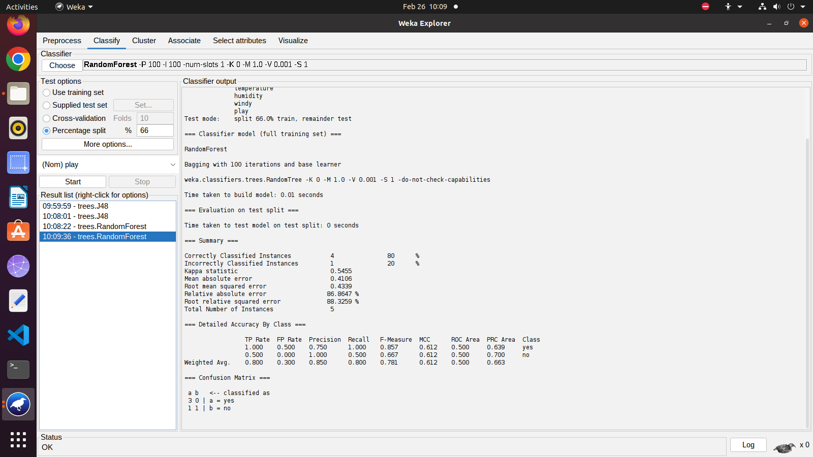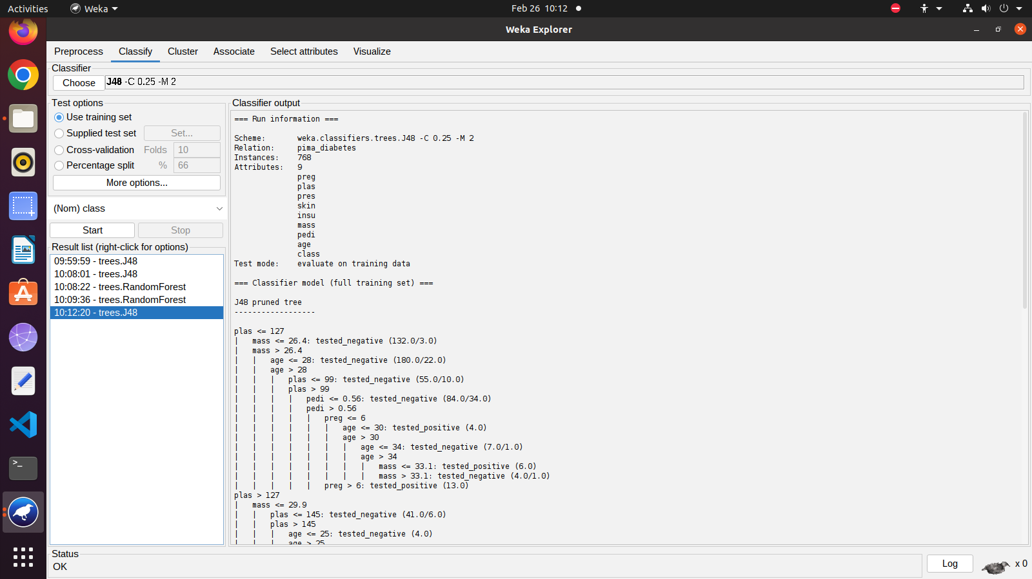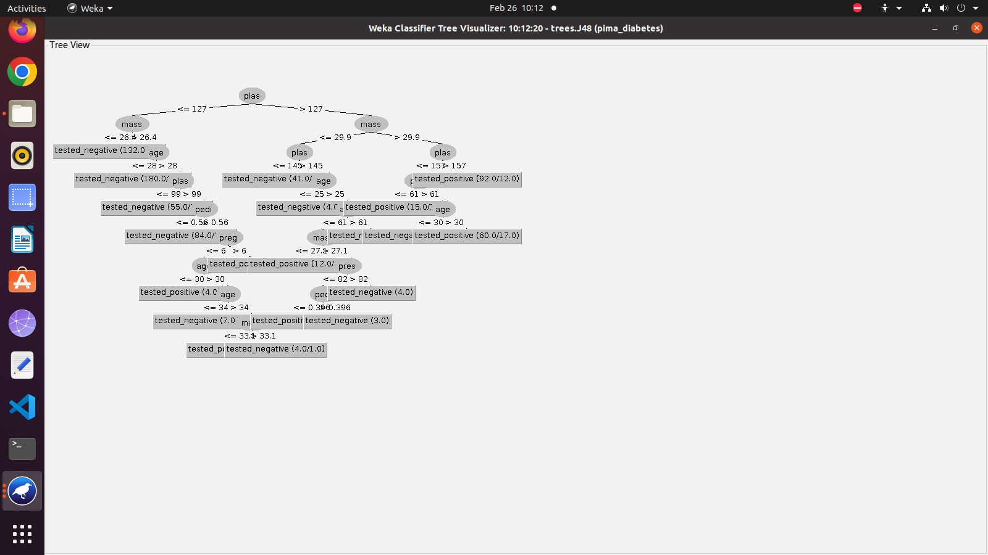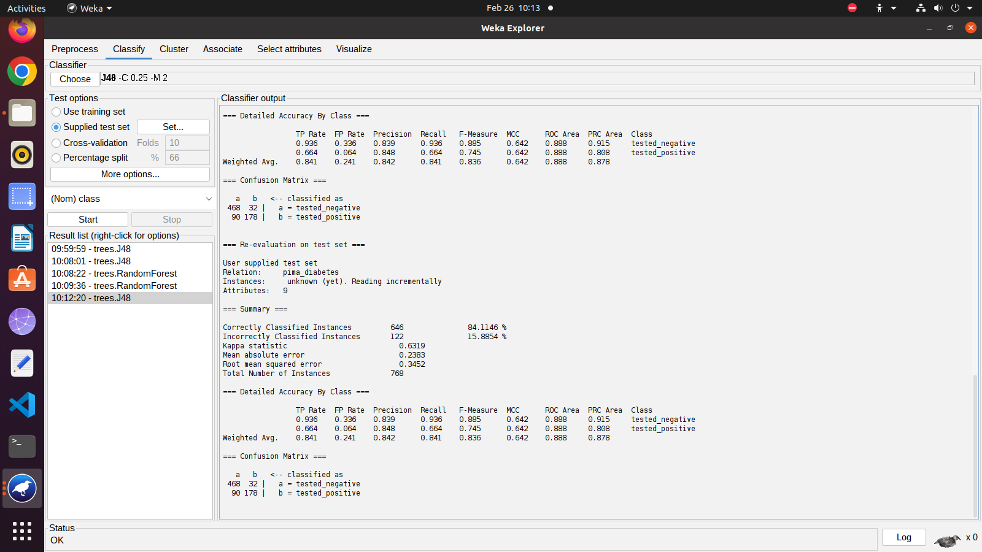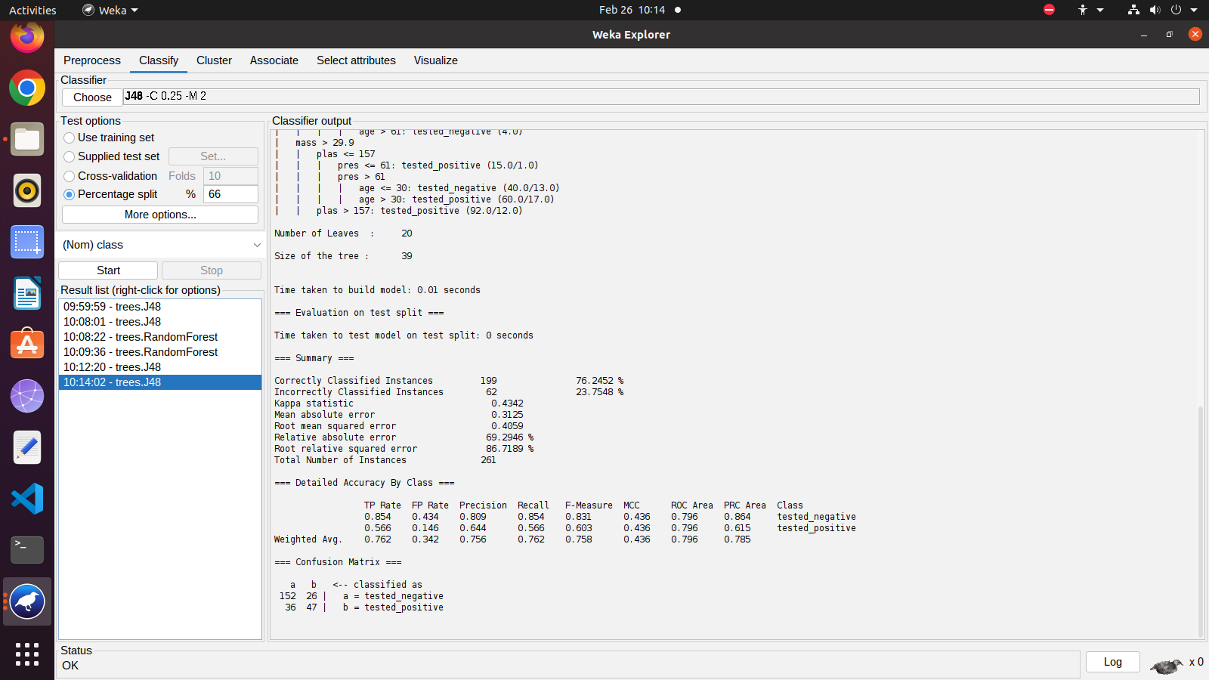

**Conclusion:** In this experiment, we learned about the classification algorithms and implemented it using Python and the WEKA software .

**Lab Outcome:** Implement various data mining algorithms from scratch using languages like Python / Java / R, etc.

**Submitted Details -**

**Name of Student: Parth Malviya**

**Roll No.: 22**

**Date of Performance: 26-2-24**

**Date of Submission: 24-3-24**